http://www.1984play.com.au/education/
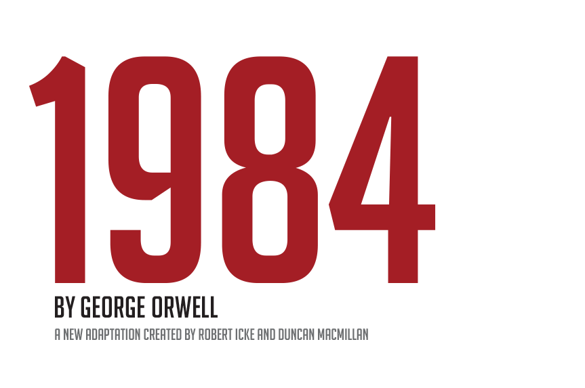
Teaching 1984 in 2017
My classroom becomes a totalitarian state every school year toward the end of October. In preparation for teaching 1984 to seniors, I announce the launch of a new program aimed at combating senioritis, a real disease with symptoms that include frequent unexplained absences, indifferent reading, and shoddy work. I tell each class that another class is largely to blame for the problem and require, for a substantial participation grade, that students file daily reports on another student’s work habits and conduct; most are assigned to another student in the same class.
We blanket the campus in posters featuring my face and simple slogans that warn against the dangers of senioritis and declare my program the only solution to the school’s woes. Last year, my program was OSIP (Organization for Senior Improvement Project); this year, it’s SAFE (Scholar Alliance For Excellence). We chant a creed at the start of each class, celebrate the revelatory reports of “heroes” with cheers, and boo those who fail to participate enthusiastically. I create a program Instagram that students eagerly follow. I occasionally bestow snacks as rewards.

After a week, new posters (and stickers) speak less to senioritis and more to, well, me. The new slogans are simpler: my name, mostly. My image is everywhere. I change the rules, requiring students to obtain more points in order to pass. I restrict previously granted privileges, like the right to leave the room to use the bathroom. I subtract points for subjectively noted lapses in conviction. I fabricate a resistance movement and vow to stamp out the ignorant opposition to our noble cause.
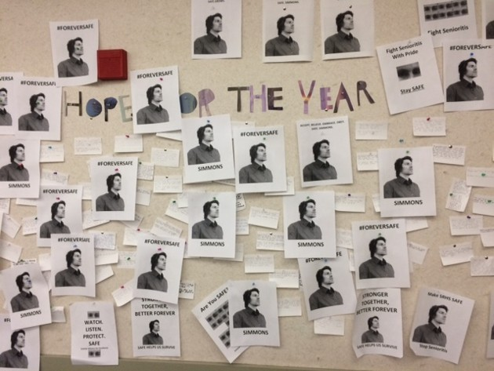
Occasionally, a kid groans in exasperation and I fix him with a long, nasty, meaningful look. If a student asks about the point of it all, I ask him why no one else seems to have the same concern. I get louder. I get meaner. I give students points for alerting me to the sources of dissent. Eager to shore up their grades, gleeful at the chance to tweak friends and possibly enemies, a few students furtively hand over notes after classes. I collect the reports two weeks after they start the book, pronounce the experiment over (with language paying tribute to Orwell’s telling appendix), and ask them what they learned.

The simulation is my favorite activity of the year. This year, it feels a little different than usual. “Make School SAFE Again,” reads the students’ main slogan for their campaign this year, which launched two weeks ago. Other posters employ a comically primitive vocabulary arranged in brutally simple syntax:

The author’s classroom-turned-totalitarian-state (Andrew Simmons)

Senioritis is a Disaster.
Senioritis is Disgusting.
Senioritis is Sad.
Senioritis is Shameful.

This year, I plumb the depths of the iffy performance instincts I honed in my high-school theater classes to attempt an increasingly belligerent swagger—a departure from my usual grinning cult leader shtick. Rampant senioritis is a problem, I warn, squinting and jabbing with a finger. I’m gonna stop it, I say. My antics and governing strategy highlight hallmarks of the superstate Oceania in 1984: An effective message should be simple, relentless, and inescapable; lies can become truths when listeners can’t conceive of alternatives; threats against free speech dampen resistance; fear of personal injury inhibits solidarity among citizens; scapegoating divides the populace; political enemies and those offering rational critical responses to tyranny are demonized. Evaluating these tactics is particularly important because my students live in a society in which they can, I believe, work spectacularly well.

Enormously well.

Tremendously well.

The 1984 unit always reflects what’s going on in the country and world. The past few years, my classes have studied the NSA, the Patriot Act, and online privacy. Right now, some of my students are afraid that their world may start to feel more like the one they’re reading about in the book and experiencing in my classroom. My school is 65 percent Latino. The white kids tend to be liberal. I teach in Marin County, in the San Francisco Bay Area. Still, Latino students arrived on the morning of November 9, some from Richmond, across the bay, and reported that a handful of white people interrupted their morning commutes to urge them to “go back to Mexico.” I live in Oakland, and at about 12:30 a.m. on that Wednesday, a few men who appeared to be drunk and white staggered down my street, shooting extremely powerful fireworks into the sky above my house, yelling that this was “the greatest day in the history of America.”

I came to school on Wednesday, but a lot of students didn’t. Many of those who came said they were afraid, confused, angry, and anxious. Many Latino students tell me of ICE raids that happened on their neighborhood a decade ago. Several recall seeing their fathers handcuffed and thrown into vans by armored, helmeted officers. Some did not see them for years. A few kids have done time in private immigration detention centers. Many have family members who came to the United States from countries abused by corrupt regimes. Maybe the kids don’t understand how America’s government works. Don’t they know that there are checks on executive power and that campaign bravado—even the cruelest sort—doesn’t necessarily follow the country’s elected presidents into the White House? Maybe the kids—some of them gay, many of them immigrants, most of them young women—worry in a histrionic, sky-is-falling fashion because they’re less touched by “real-world” concerns than adults, who, of course, know better.
Their sense of the significance of the occasion and their expression of their concerns should not be dampened. Instead, it should be viewed as the ultimate teachable moment.

Every year, when I ask students what they learned from the class simulation—my artificial teachable moment—they say they realize that loyalty isn’t as ironclad as it should be. They didn’t question why they had to spy on fellow seniors; they chuckled about the task but they did it anyway. I had a points-hungry go-getter two years ago who eagerly filed detailed supplemental reports on her boyfriend.
Students say they learned how quickly a mission supposedly for the greater good can take an unpalatable detour. They admit that they did not always immediately grasp swift changes to previously outlined rules. They admit that they followed me on Instagram without considering the risk of letting an authority figure (were he so inclined) glimpse their personal lives. They realize that they didn’t ask for details about my plan to eliminate senioritis—that they formed no serious opposition, that they just grimaced when my back was turned and whined lightly in isolation. They cared about their grades, they admit, and they thought I was funny, so they did as they were told.
For these reasons, they always fail the simulation. From their performance, they learn a lesson about their weaknesses. This is also a key lesson from 1984. Understanding it can inform their response to the direction their country might be headed.
A good teacher does not try to firm up an ideological resistance along partisan lines. Instead, a good teacher shows students how to discern clickbait from reported stories and to read both Breitbart and The New York Times, not to keep a balanced personal perspective so much as to examine how media outlets interpret and spin events. In an age when fact-checkers can provide guidance in real time and the internet swells with more information than a person can actually take in, students need to be able to read more than captions and watch clips longer than 10 seconds.
Analytical, communication, and attention deficits are a problem of education but also a social environment that has steadily required less in the way of written and verbal communication, as well as an entertainment industry that has provided content—shorter, faster, brighter, simpler—to suit that shift. Students need to hack through manipulative language, whether it be a bill’s obtuse legalese concealing bigotry or stark campaign declarations loaded with ugly connotations. They need to see books as rich, perpetual gifts to those in need of solace and inspiration, and to know that their fears have been addressed before, in more dire circumstances, and that thinkers from the past can help them anticipate the new guises of the terrors they faced.

I am ecstatic to be a teacher at this time in American history. I have a responsibility—not to transform every liberal parent’s progeny into a slightly sharper copy or radicalize future voters skeptical of politics, but to shore up their critical faculties, to make them more skilled readers, writers, and thinkers. And to also make them decent, compassionate, alert, engaged truth-seekers, neither callous, fearful Party enablers nor complacent, dead-eyed Proles who poke their iPhones and scoff at memes and chirp their discontent in brief blips of coherence. Bravery is something that people can be taught. Books may be the best teachers for what to do when the fireworks veer too close. They show students how to write their own appendix to a sad chapter that feels final. My 12th-grade classes are reading 1984. And, in an essay for another day, my ninth-grade class is halfway through To Kill a Mockingbird. Former high-schoolers who did their reading probably don’t need that story’s relevance explained.
In December 2015, a student reacted angrily when I wondered if the average social-media-enthralled 17-year-old in 2015 might not possess the reading and writing proficiency of her 1965 counterpart. I was asking students if, as with the Newspeak-besieged citizens of Oceania in 1984, a struggle to unravel and communicate complex ideas could result in the gradual erosion of those ideas themselves. It’s just different now, not worse, the student said. With the bell, 10 minutes later, she breezed toward the door. Over her shoulder, she shouted, sprightly and confident, that classes shouldn’t have to read 1984. It was too long, too confusing, and too full of words no one used anymore. Nothing that has happened in the past 365 days has made me more afraid and emboldened than that.

Directors ROBERT ICKE & DUNCAN MACMILLAN
Associate Director (Australia) COREY McMAHON
Designer CHLOE LAMFORD
Lighting Designer NATASHA CHIVERS
Sound Designer TOM GIBBONS
Video Designer TIM REID
Associate Lighting Designer MARC GOUGH
Associate Sound Designer RICHARD BELL
Associate Video Designer IAN VALKEITH

