Judith Mackrell The Guardian
Tuesday 27 September 2016
“Seeing Giselle as a member of the audience is a very different thing from seeing it as a choreographer – and knowing that, fucking hell, you’re going to have to be dealing with it yourself.”
That was the sobering thought that struck Akram Khan, whose new version of the ballet has just opened in Manchester. Before he embarked on the project for English National Ballet, he explains, he had only ever seen one performance of Giselle, and that was as a curious outsider. Originally choreographed in 1842 by Jules Perrot and Jean Coralli, the ballet comes straight from the heart of European Romanticism. Its plot is a narrative world away from Khan’s Bangladeshi heritage: the story of a young peasant heroine who is deceived by her aristocratic lover, Albrecht, but continues to adore him from beyond the grave.
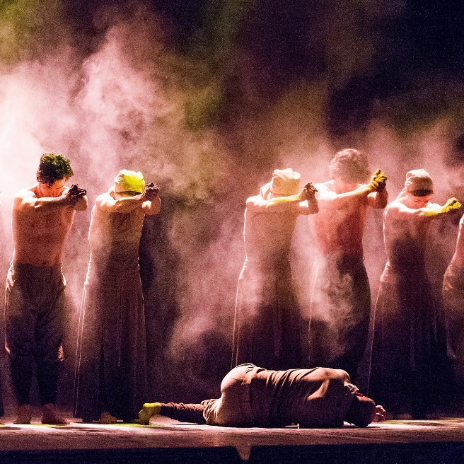
By the same measure, Giselle’s delicate, airborne vocabulary is on a completely different physical plane from the grounded, percussive language of the Indian dance form Kathak, and from the western contemporary dance styles in which Khan was trained.
Yet the world of ballet has begun scouting for its choreographers in new and sometimes surprising places, and Khan himself has been growing progressively more responsive to its call. He has collaborated with French ballerina Sylvie Guillem and in 2014 he accepted a commission from ENB’s newly appointed director, Tamara Rojo, to create a new work for the company.
That work, Dust, proved to be such a mutually satisfying experiment that Rojo then suggested Giselle. And as daunting as it was for Khan to tackle so revered a classic, he was also fascinated to discover exactly what its story, its characters and its structure might offer him as a choreographer. “It was so important to me to respect the original. With a work as sacred as Giselle, it would be easy to say ‘Fuck off’ and make something that’s the exact opposite. But I realised you have to listen to it and open yourself up to it.”
Akram Khan in Dust, 2014. Photograph: Tristram Kenton for the Guardian
This is what Khan has spent the last year doing, in collaboration with his dramaturg Ruth Little. When I speak to the pair in a small mirrored studio in ENB’S London base, they acknowledge how hard it was, at first, to get to grips with the ballet’s plot and with its accompanying Adolphe Adam score. “The story seemed naive in so many ways,” says Little, “and the music seemed so bitty and motif-led.” Each sequence was only a minute or so long, and it all seemed so different from the kind of organic unfolding that happens in Khan’s work. But, as Little points out, “the ballet hasn’t survived for no reason”, and it has been robust enough to support other radical retellings, including those by Mats Ek and Michael Keegan-Dolan.
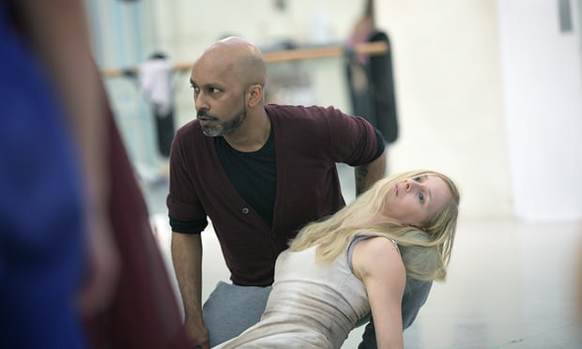
As she and Khan explored their own ideas about Giselle, they realised that the ballet’s apparently formulaic simplicity was actually its strength, and that its starkly opposed themes of love and betrayal, of reality and the supernatural, provided the power of its narrative bones. Most fruitful to them was exploring the underlying issue of power – the gulf of money and class that separates the aristocrats from the peasants in the ballet, and that dooms Albrecht and Giselle’s love to tragedy.

Akram Khan and Stina Quagebeur in rehearsal. Photograph: Laurent Liotardo
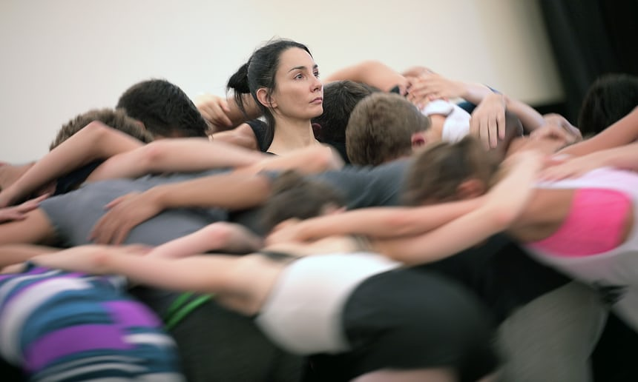
When Khan and Little began work on the project last year, the news was full of the refugee crisis in Europe and it became obvious that this would be the key to their own 21st-century Giselle. They have set the ballet among a community of migrant workers, who have been sacked from their jobs at a garment factory and are having to eke out a precarious existence in an impromptu camp. The courtly world of Albrecht is replaced by a privileged group of landlords and factory owners, who live apart from their workers behind a high wall.
Given this harsh new setting, it’s inevitable that the ballet’s heroine has also undergone profound changes. Khan says he found it hard to connect with the passive, childlike Giselle of the original, comparing her to the delicately feminised women in Kathak, who are “nearly always so shy and in awe. I hate that. [The Hindu goddess] Radha today would be chewing gum and holding out her hand for Krishna to write his telephone number on. With Giselle I wanted to create a real woman who has lived life and experienced a lot.”

|‘Visionary doggedness’ … ENB artistic director Tamara Rojo rehearses Akram Khan’s Giselle. Photograph: Laurent Liotard

What defines Giselle for Khan is not her naivety, but her capacity for hope. “She’s in this catastrophic situation but she still falls in love, she sees beauty everywhere, she’s always hoping for better things, and that’s why she’s so vulnerable to Albrecht.
Another character who fascinated him is Hilarion, the peasant gamekeeper who loves Giselle but cruelly forces her to acknowledge Albrecht’s duplicity. “He’s the most flawed and human character – he has that inner battle that always interests me.” Khan and Little have expanded Hilarion’s role in the ballet into a fixer, a go-between who works with both migrants and capitalists: “At one point I got so interested in him I had the idea of having the title as Giselle, then crossing it out and writing Hilarion in blood.”
In the process of refashioning the ballet, Khan has been working with a radical rearrangement of the score. Some of Adam’s themes and melodies will be identifiable, but he says that they have been stretched and altered by his composer, Vincenzo Lamagna, into “beautiful, interesting stuff”. In its own way, Khan’s choreography remains in dialogue with the 19th-century text, for although the dance material is all brand new, he steeped himself in the vocabulary of classicism while he was creating it. “Tamara always told me that she wanted this to be a journey for me as an artist,” he says. “It would have been a waste of time for me if I had made a work for ENB that my own dancers could have done better.”
It would have been a waste of time to make a work for ENB that my own dancers could have done better
Perhaps the most extreme journey Khan has taken is into the language of pointe work. He’s using it only in the ghostly second act (now relocated from a moonlit graveyard to an abandoned factory) but is fascinated by the gravity-defying possibilities it affords him. “This act is so otherworldly, floating and spiritual; how could I not use pointe shoes? They were developed for that purpose.”
The two principal ballerinas who will alternate in the role of Giselle are Alina Cojocaru and Rojo herself. “They are such great artists and they’ve asked so many interesting questions,” Khan says. “Tamara always looks at the whole picture of the ballet; when Alina asks questions, she always looks through the eyes of Giselle.” He would adore to partner the two ballerinas himself, but says he has created a work that is impossible for him to dance. “If I was in it I’d have to be a minor character – sort of limping and messy.”
His greatest admiration, however, is reserved for the visionary doggedness that Rojo has displayed as artistic director. In order to give Khan the time he needed to develop his material with ENB’s dancers, she has put rehearsals and performances of all other ballets on hold – a sacrifice almost unknown for a busy repertory company. “With Tamara it’s all about the art, and she really cares about this Giselle,” Khan says. “She doesn’t just want a shiny new thing – she wants a Giselle that has a life and a future. I’m not saying I can make it happen, but it’s the aspiration for us all.

https://www.youtube.com/watch?v=cs2nsC_pchw

