The Far Side of the Moon
The Far Side of the Moon concentrates on the conflict between two brothers who are trying to come to grips with the death of their mother. It is also concerned with Russian cosmonaut Leonov, confronted with the immensity of interplanetary space as he took his first steps out of the Voskhod 2 spacecraft.
It brings forth a mad but sincere project for a space elevator that would allow humans to confront the Void.
And it also sees a goofy but touching video recording by the main character sent out to space, in an attempt to show potential extraterrestrial viewers the poetry that sometimes hides in human daily life.
This solo show by Robert Lepage, also performed by Yves Jacques, premiered in Quebec City in March 2000 and has since been shown in over forty-five cities all over the world.
EX MACHINA
In 1994, when Robert Lepage asked his collaborators to help find a name for his new company, he had one condition: the word theatre could not be part of the name.
Ex Machina is thus a multidisciplinary company bringing together actors, writers, set designers, technicians, opera singers, puppeteers, computer graphic designers, video artists, contortionists and musicians.
Ex Machina’s creative team believes that the performing arts - dance, opera, music - should be mixed with recorded arts - filmmaking, video art and multimedia. That there must be meetings between scientists and playwrights, between set painters and architects, and between artists from Québec and the rest of the world.
New artistic forms will surely emerge from these gatherings. Ex Machina wants to rise to the challenge and become a laboratory, an incubator for a form of theatre that will reach and touch audiences from this new millennium
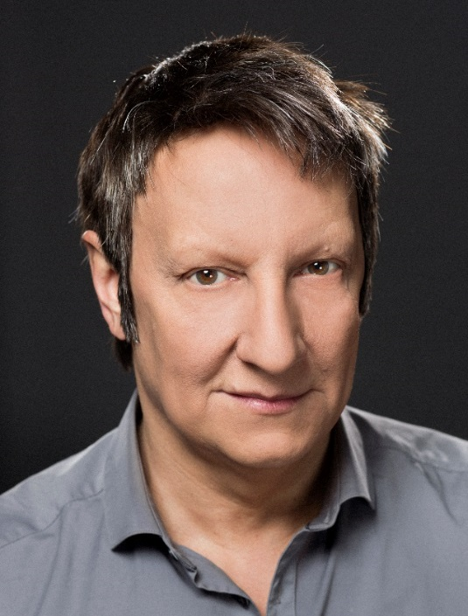
ROBERT LEPAGE
Versatile in every form of theatre craft, Robert Lepage is equally talented as a director, playwright, actor and film director. His creative and original approach to theatre has won him international acclaim and shaken the dogma of classical stage direction to its foundations, especially through his use of new technologies.

He graduated from the Conservatoire d’art dramatique de Québec and studied in Paris in 1978. In 1984, his play Circulations toured Canada. Followed The Dragons’ Trilogy (1985), Vinci (1986), Polygraph (1987) and Tectonic Plates (1988).

From 1989 to 1993 he was Artistic Director of the Théâtre français at the National Arts Centre in Ottawa. Meanwhile pursuing his own creative projects, he directed Needles and Opium (1991), Coriolanus, Macbeth, and The Tempest (1992). With A Midsummer Night’s Dream in 1992 he became the first North American to direct a Shakespeare play at the Royal National Theatre in London.
In 1994, he founded Ex Machina, then wrote and directed his first feature film, Le Confessional. Followed Polygraph (1996), Nô (1997), Possible Worlds (2000), and The Far Side of the Moon (2003). In 2013, he co-directs Triptych with Pedro Pires, an adaptation of the play Lipsynch.
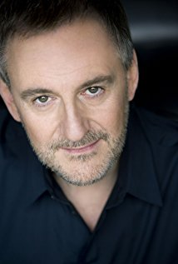
YVES JACQUES
His career led him from his native Quebec City to Montreal, then Paris where he’s been playing since, on stage as well as in movies. On stage, he has been touring worldwide for almost ten years with two Robert Lepage’s plays, The Far Side of the Moon (from 2001) and The Andersen Project (from 2007) in their French and English versions.
Yves Jacques was appointed Chevalier de l’Ordre des Arts et des Lettres by the French Ministry of Culture and Communication,
He is an Officer of the Order of Canada since 2009 for his achievements as an actor in theater, television and film, in Canada and abroad.

Robert Lepage's journey to the Far Side of the Moon
The theatre artist reflects on the loss, and the washing-machine door, that launched a beloved play.
Alexander Varty October 24th, 2012
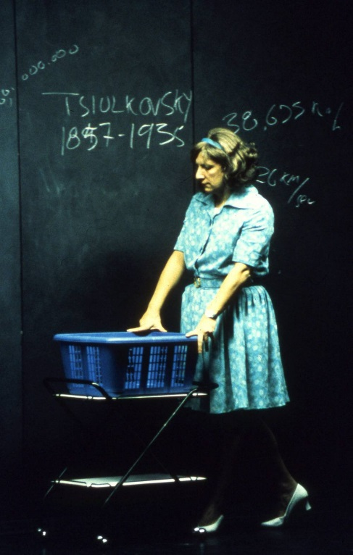
Inspiration hits at the strangest times and in the most unlikely places—as Robert Lepage discovered while moping through Quebec City during a rare creative lull some years ago. At the time, he was still mourning the death of his mother, and wondering how he could put his conflicting feelings of loss and liberation into theatrical form.
“I always had these nightmares where suddenly there was no gravity—that the day my parents weren’t there anymore, suddenly I’d start disappearing into space,” he reveals, reached in New York City during rehearsals for the Metropolitan Opera’s new production of The Tempest, which he’s directing. “This was a horrible nightmare when you’ve seen 2001: A Space Odyssey and you’ve seen the guy disappearing and screaming and you can’t hear him. So that was kind of a stress.
“My father died first,” he adds. “And then when my mom passed away, it didn’t feel like that at all. I suddenly felt so connected to life: suddenly life had a different taste, and I had this urgency to live fully—to eat and taste things and to be very, very, very, very much alive. So it was a very odd impression that I wanted to express.”
Lepage was also struggling with trying to tell the story of Buzz Aldrin, the second human ever to walk on the moon.
“I even got to speak to him a couple of times on the phone—which was a bit odd, actually. We forget that these guys are actually military men,” he notes. “And he agreed to do something, but he was always calling it ‘the TV project’, or he was calling it ‘the film project’, and I was trying to explain, ‘Well, I’m doing theatre.’ And he wanted to have complete control over everything. It became hell, basically.”
Then serendipity struck.
“I was walking in an alleyway and saw an industrial-washing-machine door that was in a garbage can,” he recalls. “It was a beautiful object, really beautiful, and I looked at it and that object seemed to contain both shows. The show about my mother, because it reminded me of when the washing machine at home would break and we would go to the laundromat in the ’60s. That would always be a great day, because I’d pretend I was at mission control. And at the same time it really looked like the porthole of some kind of lunar module, or some kind of spaceship. So that tiny object suddenly seemed to be literally a door to explore both themes. With a few more elements—just a blackboard and a couple of chairs—there’s this whole show that came out.”
Although the piece debuted in Quebec City in 2000, in typical Lepage fashion it remains a work in progress. “I performed it a lot—like, a whole lot—and when I stopped performing it this other guy [Yves Jacques] stepped in. And you look at the show and you listen to the script, and you go, ‘Oh, my God, this is horrible.’ So it’s good to have somebody step into your shoes, because you have a real chance to get a sense of what it’s really about.
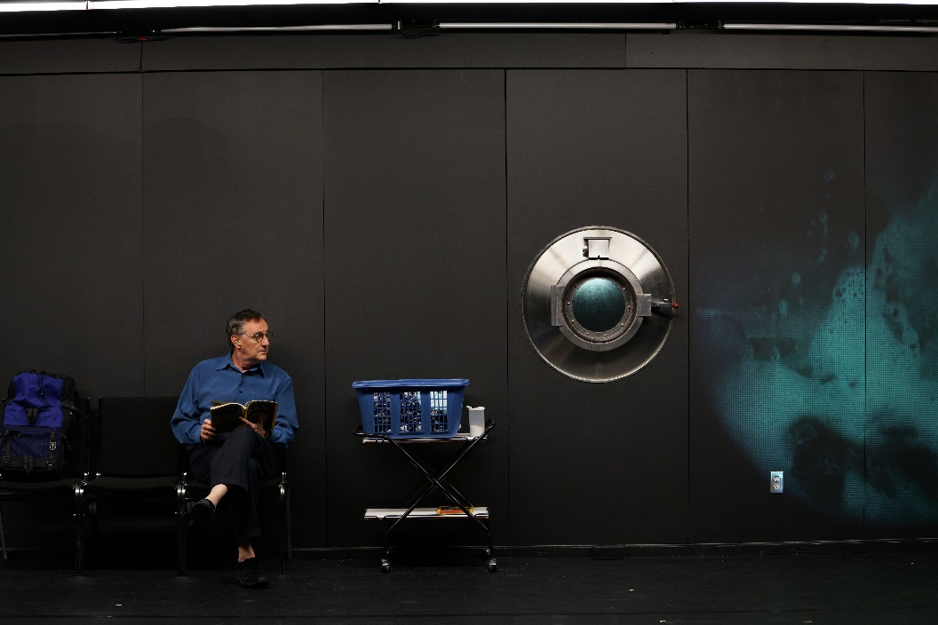
“So I kind of rewrote it and rehacked at it, did all this work.…And recently I’ve been going through it again, because I’m actually performing it, and when I was reading it I went, ‘My God, this needs another rewrite.’ But in the meantime I’ve been doing a few plays where you learn that simple is good, and short is long, and long is bad. So I guess in Vancouver, by the time I get to perform it, it’s a new script. But it’s basically the same show and the same story: it’s just the words that change.”
The new and presumably improved Far Side of the Moon also a sign of his growing engagement with Vancouver-based or -trained artists, including Kidd Pivot dancer and choreographer Crystal Pite.
Working with other, equally skilled artists is just one reason why, 28 years after his first major production, Lepage continues to be in love with theatre, even though he’s also explored film, concert design, and opera. Isolation is one of his favourite themes, but the theatrical life is anything but lonely.
“I’ve chosen to work in theatre more than any other artistic expression because it doesn’t exist without a community,” he stresses. “Even if you do a one-man show, even if you’re alone on-stage, you’re not really alone: there’s a community of people, a group of people, that surrounds you to help you out. I’m interested in that paradox: you feel lonely, you want to express loneliness, but you’re in a crowd, actually. You have a whole crowd of people helping you out, doing it.”

