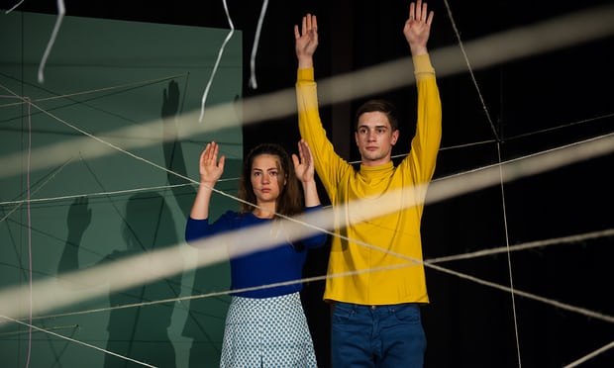
The Guardian
Wednesday 11 January 2017
US / THEM
‘I’m always up for a bit of a challenge,” says director Carly Wijs cheerfully. “The challenge with Us/Them is whether it is possible to make a children’s theatre piece that talks intelligently, meaningfully and sensitively about terrorism.”
On 1 September 2004, the children at School No 1 in Beslan, North Ossetia, were celebrating the start of a new term when an armed group demanding Chechen independence attacked the building. For 52 hours, while desperate families and Russian special forces gathered outside, more than 1,000 parents, teachers and children were held hostage in the school gym in sweltering conditions.
Roman van Houtven and Gytha Parmentier in Us/Them at Summerhall, Edinburgh, in 2016. Photograph: Murdo MacLeod for the Guardian
The siege came to an end when one of the bombs in the booby-trapped gymnasium exploded in circumstances still not fully explained and a shootout between the terrorists and the army ensued as fire ravaged the school. Three hundred and thirty-four people died, including 186 children.
The stuff of nightmares, it might seem an unpromising and possibly even offensive subject for a theatre show made for young audiences. But Wijs’s production sweeps aside all doubts in an astonishingly assured, frequently playful, sometimes surprisingly jokey – and ultimately desperately moving – show in which the events of the siege are told entirely through the eyes of two (fictional) children.
Us/Them, which arrives at the National Theatre this month after a sell-out run last summer at the Edinburgh fringe, begins with a boy and girl squabbling over how to chalk out a map of their town and school. It’s vitally important they get it right, but their memories differ. They bicker, make up and then carry on, the concentration showing in their faces.
Gradually it becomes clear that this is more than just a game. It is a way of dealing with internalised trauma and of replaying a story when words fail. By the end of the show, the carefully constructed map will be nothing but dust. Tomorrow, the map and the story must be constructed again.
It was Wijs’s son who gave her the idea for Us/Them. He was eight at the time that the Brussels-based director was casting around for an idea after Belgium’s Bronks theatre commissioned her to make her first children’s show. Her son was starting to look outwards and was getting to grips with the world that existed beyond his home, family, friends and school. “He saw a news item about the attacks on the Westgate mall in Nairobi and I was struck by the matter-of-fact, very distanced way that he spoke about what happened. I was interested in how different his response was to the emotional way an adult would react to such news.
Even so, the show initially proved a difficult sell, even in liberal Flanders where parents are more relaxed about what is and isn’t suitable for children to see in the theatre. Yet a play made for children about a terrorist incident that claimed the lives of so many was at first deemed a step too far by some venues. “People said it wouldn’t look good in the brochure,” recalls Wijs.
She says her lack of experience at making work for children made her braver about tackling a tricky subject. “I didn’t know my audience. All I know is my own son and what he can manage, so that was my audience. Maybe I’m a bit more robust with my child than other people, but he was my mirror.”
For those who questioned the sensitivity of making a piece about the siege, she countered: “I’m not making a performance for the children of Beslan, I’m making a performance for children in Europe to talk about stuff that is really far away but which is happening and must be confronted.”
A year later – by which time the show had been seen by programmers at the 10 venues brave enough to host it and booked into a further 50 theatres in Belgium and France the Paris and Brussels attacks brought terrorism much closer to home. In Wij’s case, within 100 metres of her front door.
“Initially I had thought that one of the reasons Us/Them worked was because it was something that had happened far away and we could look at it with a distant eye. But now the kids in Brussels have been affected by terrorism. The show communicates immediately to them and provides a way of thinking and talking about terrorism and its realities.”
Us/Them may have been made for young audiences, but there is nothing remotely childish about a piece that constantly raises questions about perception and the way we view those who are different to ourselves as “other”.
The devastating final 15 minutes, where the truth appears as several versions, are an acute inquisition into how myths and stories are made. They reveal the ways the media and those with vested interests can manipulate the truth and use images to influence our perception of events.
Isn’t that too complicated for children? Wijs thinks not, pointing to the American election and fake news stories as reasons why it’s vitally important for young people and adults to question what they are told.
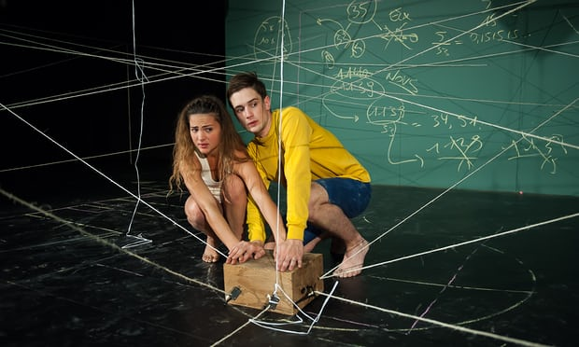
“Us/Them has multiple endings, and maybe some of them are part of the truth of what happened and some are not. It’s up to the audience to make up their own minds.”

